**Day 3:**

**1.overloading:**

class Calc {

public String area(String a,int b) {

return a + b*b; //order

}

public String area(double r,String a) {

return a + Math.PI*r*r; //order

}

public double area(double a, double b) {

return 0.5*a*b; //type of

}

public int area(int a, int b) {

return a*b; //number of , type of

}

public int area(int a, int b, int c) {

return a*b*c; //number of

}

}

public class Area {

public static void main(String[] args) {

Calc obj = new Calc();

System.out.println("Area of " + obj.area("Square",12));

System.out.println("Area of " + obj.area(7.5,"Circle"));

System.out.println("Area of Triangle :" + obj.area(11.5,14.7));

System.out.println("Area of Rectangle :" + obj.area(11,17));

System.out.println("Area of Cuboid :" + obj.area(11,13,15));

}

}

Output:

Area of Square144

Area of Circle176.71458676442586

Area of Triangle :84.52499999999999

Area of Rectangle :187

Area of Cuboid :2145

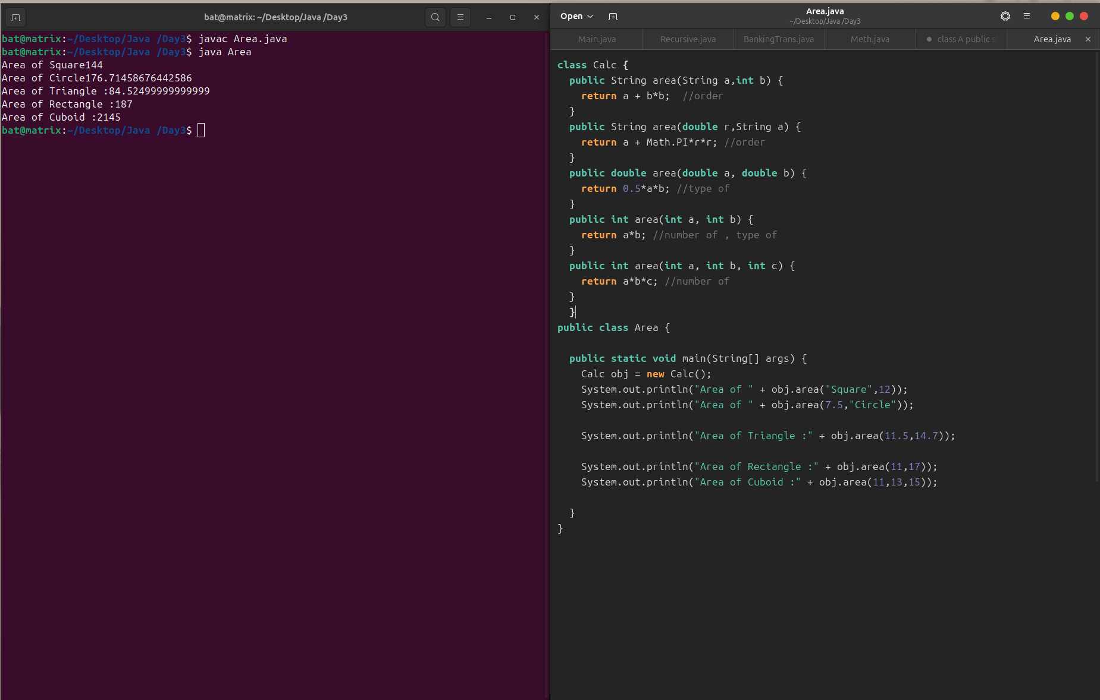

**2.Bank Transaction with a note added and transaction history using linked list and tried to include method overloading.**

import java.util.*;

public class BankingTrans {

static class Account {

String accno;

String acchname;

double balance;

LinkedList<String> transactions;

public Account(String accno, String acchname, double balance) {

this.accno = accno;

this.acchname = acchname;

this.balance = balance;

this.transactions = new LinkedList<>();

transactions.add("Opening Balance : Rs. " + balance);

}

public void deposit(double amount) {

if (amount > 0) {

balance += amount;

String msg = "Deposited Rs. " + amount + "\n Available Balance Rs. " + balance;

transactions.add(msg);

System.out.println(msg);

} else {

System.out.println("Enter valid amount");

}

}

public void withdraw(double amount) {

if (amount > 0 && balance >= amount) {

balance -= amount;

String msg = "Withdrawal of Rs. " + amount + " Success"+ "\n Current Balance Rs. " + balance;

transactions.add(msg);

System.out.println(msg);

} else if (amount <= 0)

System.out.println("Enter positive values only");

else

System.out.println("Insufficient balance");

}

public void transfer(double amount, String reason) {

if (amount > 0 && balance >= amount) {

balance -= amount;

String msg = "Transfer of Rs. " + amount + " Success " + " Reason :" + reason ;

transactions.add(msg);

System.out.println(msg);

} else if (amount <= 0)

System.out.println("Enter positive values only");

else

System.out.println("Insufficient balance");

}

public void transfer(String reason, double amount) {

if (amount > 0 && balance >= amount) {

balance -= amount;

String msg = "Transfer of Rs. " + amount + " Success " + " Reason :" + reason ;

transactions.add(msg);

System.out.println(msg);

} else if (amount <= 0)

System.out.println("Enter positive values only");

else

System.out.println("Insufficient balance");

}

public void addmoney(double amount) {

if (amount > 0) {

balance += amount;

String msg = "Updated Balance of Receiver: Rs. " + balance;

transactions.add(msg);

System.out.println(msg);

} else {

System.out.println("Enter valid amount");

}

}

public void showTransactions() {

System.out.println("\n====Transaction History==== \n Account Number : "+ accno);

for (String t : transactions) {

System.out.println(t);

}

}

public double getBalance() {

return balance;

}

public String getAccno() {

return accno;

}

public String getAccinfo() {

return "Account Number: " + accno + ", Account Holder Name: " + acchname + ", Balance: Rs. " + balance;

}

}

static class Bank {

public List<Account> accounts;

public Bank() {

this.accounts = new ArrayList<>();

}

public void addAccount(Account account) {

accounts.add(account);

System.out.println("Adding account to the Bank");

}

public Account findAccount(String accno) {

for (Account account : accounts) {

if (account.getAccno().equals(accno)) {

return account;

}

}

return null;

}

}

public static void main(String[] args) {

Scanner sc = new Scanner(System.in);

Bank bank = new Bank();

int choice;

do {

System.out.println("\n====== Bank ====== \n 1. Create Account \n 2. Deposit \n 3. Withdraw \n 4. View Account \n 5. Perform Transaction \n 6. View Transactions \n 7.Exit \n Enter your Choice : ");

choice = sc.nextInt();

sc.nextLine();

switch (choice) {

case 1:

System.out.print("Enter Account Number: ");

String accNo = sc.nextLine();

System.out.print("Enter Account Holder Name: ");

String accName = sc.nextLine();

System.out.print("Enter Initial Balance: ");

double initBal = sc.nextDouble();

sc.nextLine();

Account acc = new Account(accNo, accName, initBal);

bank.addAccount(acc);

break;

case 2:

System.out.print("Enter Account Number: ");

String depAccNo = sc.nextLine();

Account depAcc = bank.findAccount(depAccNo);

if (depAcc != null) {

System.out.print("Enter amount to deposit: ");

double amount = sc.nextDouble();

sc.nextLine();

depAcc.deposit(amount);

} else {

System.out.println("Account not found.");

}

break;

case 3:

System.out.print("Enter Account Number: ");

String withAccNo = sc.nextLine();

Account withdrawAcc = bank.findAccount(withAccNo);

if (withdrawAcc != null) {

System.out.print("Enter amount to withdraw: ");

double amt = sc.nextDouble();

sc.nextLine();

withdrawAcc.withdraw(amt);

} else {

System.out.println("Account not found.");

}

break;

case 4:

System.out.print("Enter Account Number: ");

String infoAccNo = sc.nextLine();

Account infoAcc = bank.findAccount(infoAccNo);

if (infoAcc != null) {

System.out.println("Account Found!");

System.out.println(infoAcc.getAccinfo());

} else {

System.out.println("Account not found.");

}

break;

case 5:

System.out.print("Enter Sender Account Number: ");

String senderAccNo = sc.nextLine();

Account senderAcc = bank.findAccount(senderAccNo);

if (senderAcc != null) {

System.out.print("Enter Receiver Account Number: ");

String receiverAccNo = sc.nextLine();

Account receiverAcc = bank.findAccount(receiverAccNo);

if (receiverAcc != null) {

System.out.print("Enter transaction details: ");

double amt = sc.nextDouble();

sc.nextLine();

String note = sc.nextLine();

senderAcc.transfer(amt,note);

receiverAcc.addmoney(amt);

} else {

System.out.println("Receiver Account not found.");

}

} else {

System.out.println("Sender Account not found.");

}

break;

case 6:

System.out.println("Enter Account Number: ");

String taccno = sc.nextLine();

Account tacc = bank.findAccount(taccno);

if (tacc != null) {

tacc.showTransactions();

}

else {

System.out.println("Account not found...");

}

break;

case 7:

System.out.println("*** Thanking you! ***");

break;

default:

System.out.println("Enter a valid option only ...");

}

} while (choice != 7);

sc.close();

}

}

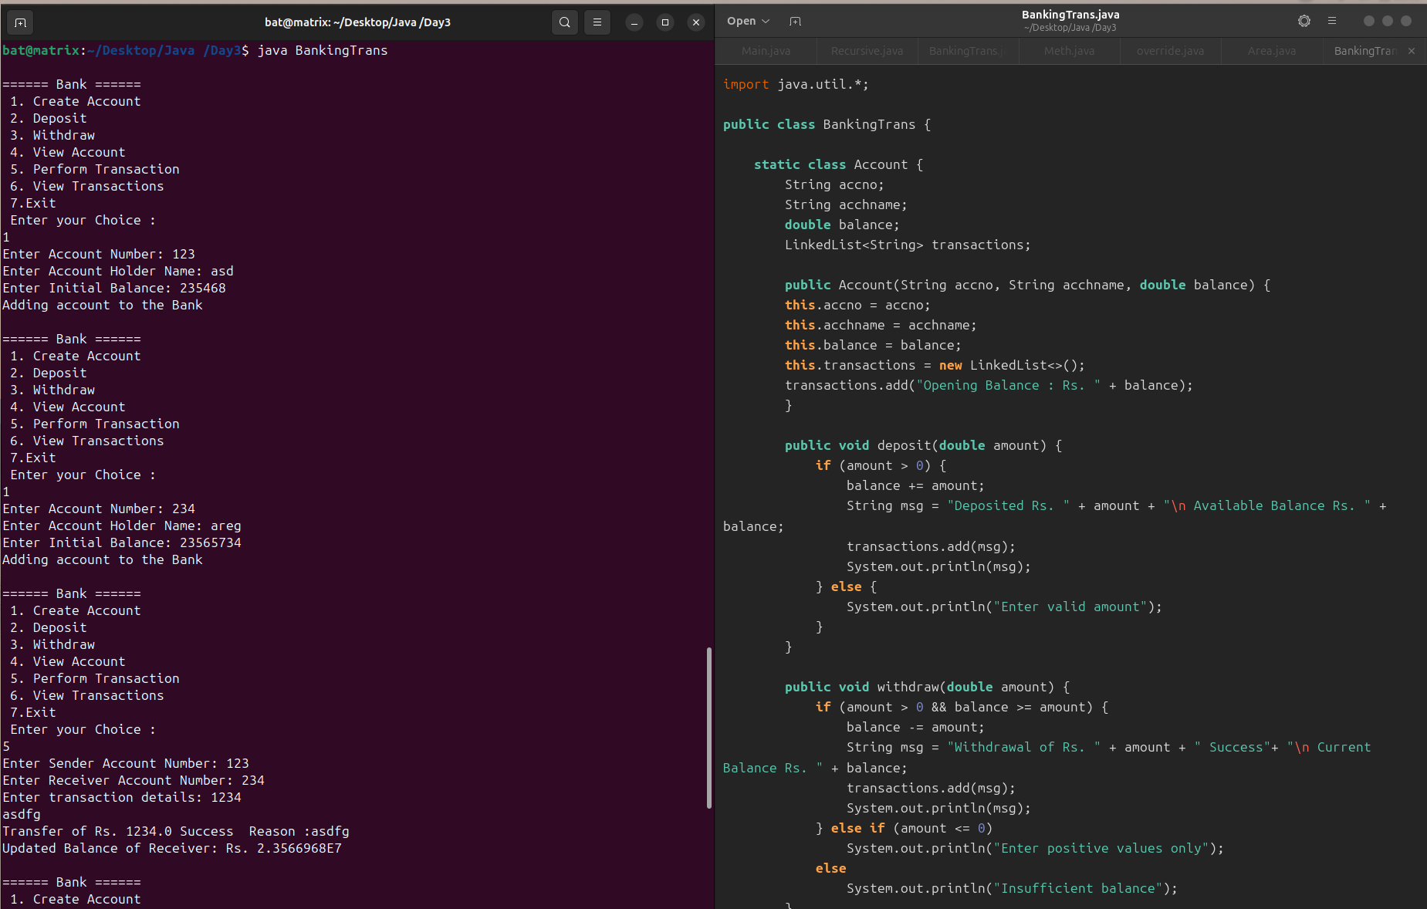

Output:

===== Bank ======

1. Create Account

2. Deposit

3. Withdraw

4. View Account

5. Perform Transaction

6. View Transactions

7.Exit

Enter your Choice :

1

Enter Account Number: 123

Enter Account Holder Name: asd

Enter Initial Balance: 235468

Adding account to the Bank

====== Bank ======

1. Create Account

2. Deposit

3. Withdraw

4. View Account

5. Perform Transaction

6. View Transactions

7.Exit

Enter your Choice :

1

Enter Account Number: 234

Enter Account Holder Name: areg

Enter Initial Balance: 23565734

Adding account to the Bank

====== Bank ======

1. Create Account

2. Deposit

3. Withdraw

4. View Account

5. Perform Transaction

6. View Transactions

7.Exit

Enter your Choice :

5

Enter Sender Account Number: 123

Enter Receiver Account Number: 234

Enter transaction details: 1234

asdfg

Transfer of Rs. 1234.0 Success Reason :asdfg

Updated Balance of Receiver: Rs. 2.3566968E7

====== Bank ======

1. Create Account

2. Deposit

3. Withdraw

4. View Account

5. Perform Transaction

6. View Transactions

7.Exit

Enter your Choice :

5

Enter Sender Account Number: 1233

Sender Account not found.

====== Bank ======

1. Create Account

2. Deposit

3. Withdraw

4. View Account

5. Perform Transaction

6. View Transactions

7.Exit

Enter your Choice :

5

Enter Sender Account Number: 123

Enter Receiver Account Number: 234

Enter transaction details: asdaf

Exception in thread "main" java.util.InputMismatchException

at java.base/java.util.Scanner.throwFor(Scanner.java:947)

at java.base/java.util.Scanner.next(Scanner.java:1602)

at java.base/java.util.Scanner.nextDouble(Scanner.java:2573)

at BankingTrans.main(BankingTrans.java:192)